Добридник Світлана ІП-02

Варіант 18

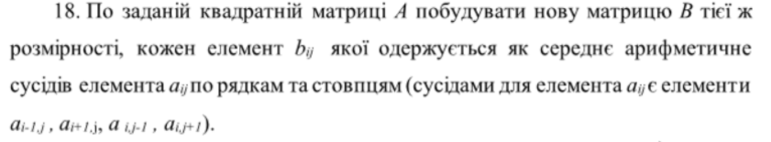

Блок-схема:

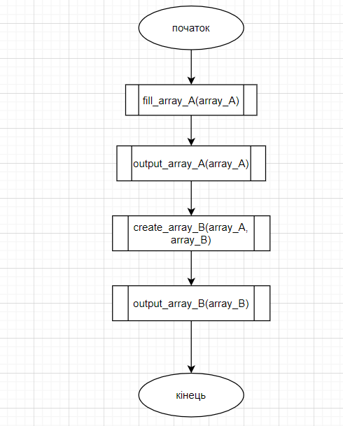

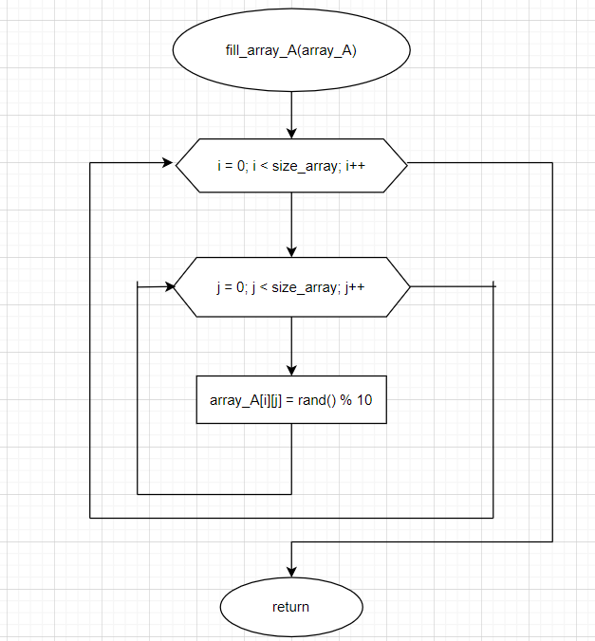

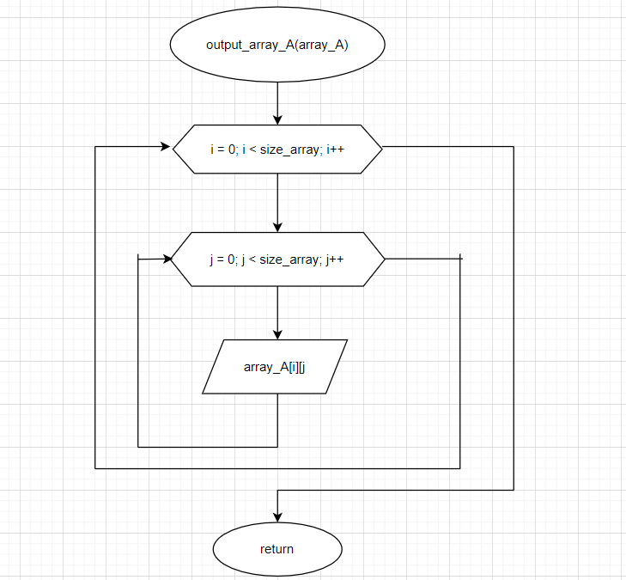

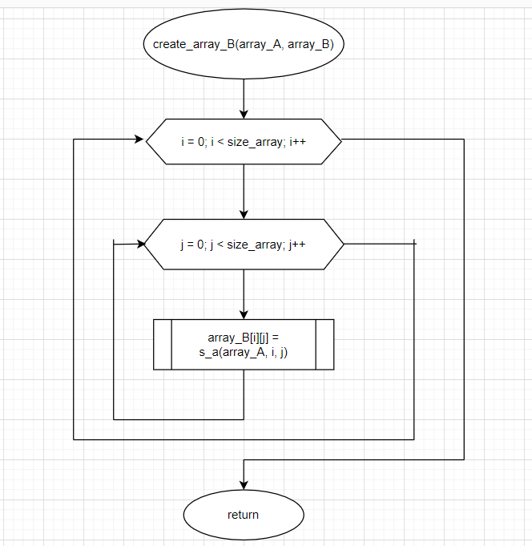

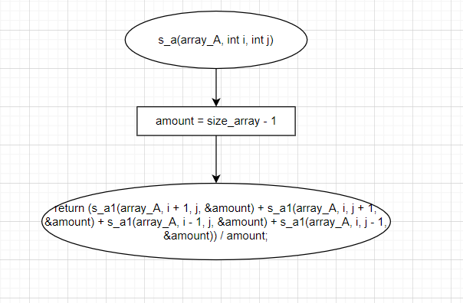

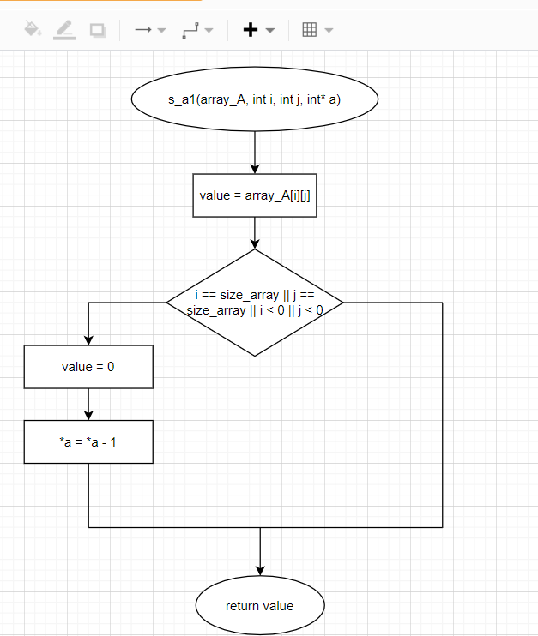

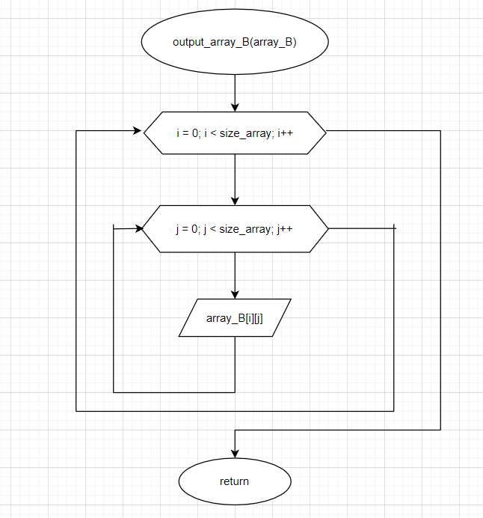

Код на С++:

#include <iostream>

#include <ctime>

#include <iomanip>

using namespace std;

int const size_array = 5;

typedef float matrix_A[size_array][size_array];

typedef float matrix_B[size_array][size_array];

matrix_A array_A;

matrix_B array_B;

void fill_array_A(matrix_A);

void output_array_A(matrix_A);

float s_a1(matrix_A, int, int, int*);

float s_a(matrix_A, int, int);

void create_array_B(matrix_A, matrix_B);

void output_array_B(matrix_B array_B);

int main() {

fill_array_A(array_A);

output_array_A(array_A);

cout << "==============================" << endl;

create_array_B(array_A, array_B);

output_array_B(array_B);

system("pause");

}

void fill_array_A(matrix_A array_A) {

srand(time(NULL));

for (int i = 0; i < size_array; i++) {

for (int j = 0; j < size_array; j++) {

array_A[i][j] = rand() % 10;

}

}

}

void output_array_A(matrix_A array_A) {

for (int i = 0; i < size_array; i++) {

for (int j = 0; j < size_array; j++) {

cout << setw(5) << array_A[i][j];

}

cout << endl;

}

}

float s_a1(matrix_A array_A, int i, int j, int* a) {

int value = array_A[i][j];

if (i == size_array || j == size_array || i < 0 || j < 0) {

value = 0;

*a = *a - 1;

}

return value;

}

float s_a(matrix_A array_A, int i, int j) {

int amount = size_array - 1;

return (s_a1(array_A, i + 1, j, &amount) + s_a1(array_A, i, j + 1, &amount) + s_a1(array_A, i - 1, j, &amount) + s_a1(array_A, i, j - 1, &amount)) / amount;

}

void create_array_B(matrix_A array_A, matrix_B array_B) {

for (int i = 0; i < size_array; i++) {

for (int j = 0; j < size_array; j++) {

array_B[i][j] = s_a(array_A, i, j);

}

}

}

void output_array_B( matrix_B array_B) {

for (int i = 0; i < size_array; i++) {

for (int j = 0; j < size_array; j++) {

cout << setw(12) << array_B[i][j] << "\t ";

}

cout << endl;

}

}

